|  |  |
| --- | --- |
| **N. Raghavan**, FNAE, FICE(UK), FIE(I)  **Email:** [**Nraghavan@iitm.ac.in**](mailto:Nraghavan@iitm.ac.in)**;** [**Nraghavan01@Gmail.com**](mailto:Nraghavan01@Gmail.com) **Mob:** +91 98409 75176 Age: 71 | C:\Users\Anupama Raghavan\Documents\NRG\HP laptop copy\Photos\N Raghavan Apr 2015.jpg |

**Brief Curriculum Vitae**

1. **EARNED DEGREES**
   * Bachelor of Technology (Civil Engg.), Indian Institute of Technology, Madras, 1970
   * Master of Technology (Structural Engg.), Indian Institute of Technology, Bombay, 1976
2. **RECOGNITIONS**
   * Elected Fellow of Indian National Academy of Engineering (FINAE), Institution of Civil Engineering (UK), Institution of Engineers (India).
   * SB Joshi Memorial Award for Excellence in Bridges & Structures, COEP, 2008
   * Best Overseas Article Award- Energy Jr of ICE (UK) on Underground Cavern Project in Vizag
   * Dr. Ramaiah Endowment Lecture for ICI, 2014
   * Dr. C S Viswanatha Memorial Lecture for ICI, 2016
   * P. S. Rajagopalan Endowment Lecture for Anna Univ.,2017
3. **CURRENT POSITIONS**
   * Professor of Practice, BTCM division, Department of Civil Engineering, Indian Institute of Technology Madras.
   * Director-Institute for Lean Construction Excellence (ILCE)

* Independent Director -Vadodara-Bharuch Toll Roads Ltd, Panipat Elevated Corridor Ltd., L&T Transportation Infrastructure Ltd
* Member, INAE Forum on Civil Infrastructure (Traffic & Transportation, Housing)

1. **PREVIOUS POSITIONS**
   * Retired as Member of Top Management of L&T-ECC Construction Division; Head- Hydro & Nuclear Power Sector and Underground Works
   * Founder Chief Executive - L&T- Ramboll Consulting Engineers Ltd; Today the company is known as L&T Infrastructure Engineering Ltd.
   * Principal Consultant- STUP Consultants Ltd; Head of New Bombay Office
   * Director/ Member of the Board of: L&T-Ramboll Consulting Engineers Limited, L&T Power Development Limited, L&T Uttaranchal Hydro Power Limited. TRIL Infopark Ltd., Western india Tollbridge Ltd., Western Andhra Transportation Ltd, Krishnagiri Thoppur Transportation Ltd
   * Chairman, Research Council, CSIR-Central Building Research Institute, Roorkee
   * Associate President: Indian National Hydropower Association; Member of International Hydropower   
      Association
   * Member-INAE SC-I Committee- Civil Engineering;
   * Subject Expert- AICTE Committee for Quick Revision of Model Curriculum in U/G Engg. Courses: Civil Engg.; Sub-committee for Guidelines for INAE Young Engineer Award;
   * Member, Management Committee, Sri Ramakrishna Mission Ashrama, Chennai
2. **PRESENT & PAST PROFESSIONAL AFFILIATIONS**
   * Elected Fellow of Indian National Academy of Engineering; Fellow of Institution of Civil Engineers (UK), Fellow of Institution of Engineers (India)
   * Current & Past Member of: Indian Concrete Institute, Indian Roads Congress, International Association for Bridge and Structural Engineering, Indian Institution of Bridge Engineers; Indian Institution of Wind Engineers, Institute of Concrete and Fibre-Reinforced Concrete, Institute of Urban Transport (India), Association of Consulting Civil Engineers.
   * Chairman of Conf. of International Association for Computer Methods and Advances in Geomechanics (IACMAG)- Goa 2008; Co-Chairman of Nuclear Power Experts Group for Power India 2006 International Conference; Member of the Apex Advisory Council & Hydro Power Experts Group, National Steering Committee for Power India International Conference. Member of CII Trade Delegation to Budapest, Hungary along with Minister of Commerce, 2000.
   * IRC- H7 Committee for Highway Tunnels Code of Practice
   * WRD 21 of BIS- Safety in Construction, Operation and Maintenance of River Valley Projects Sectional Committee
   * BIS committees on Natural Draught Cooling Towers, etc.
   * IRC committees on Bearings, etc.
   * Member of Task Force of GOI Power Ministry for formulating standard contract implementation documents for Hydro power projects
   * Member of IITM Group for Indian Neutrino Observatory
   * Editorial Advisory Boards of Power Stream, Enertia journals
   * Member of ICI Task Force on Handbook for Precast Concrete Construction
   * Convener for the infrastructure Panel of CII (Confederation of Indian Industries), Tamil Nadu
   * Member of CII TN State Council, Member of CII (Southern Region) Working Group on Ports
   * Member of FICCI TN State Panel
   * Member of Executive Committee of ICE (UK) Chennai Chapter
   * Member of Executive Committee of Indian Concrete Institute, Tamil Nadu Chapter
   * Member of Task Committee (Dr Nagesh Iyer), FNAE working on Engineering Education   
      Scenario for INAE’s Vision 2012 document.
3. **CONTRIBUTIONS TO IIT MADRAS**
   * Vice President- Exec Council, IIT Madras Alumni Association;
   * One of the two Founders & Vice President- IIT AIIC/ IIT Alumni Club
   * Produced Films for IITMAA: Alumni Care- I, Alumni Care-II
   * Visiting Faculty – First ever Professor of Practice of IITM, BTCM Division, Department of Civil Engineering, Indian Institute of Technology Madras (since 2017); Earlier: Adjunct Professor, AICTE- INAE Distinguished Professor for several years
   * Participated in many consultancy and research assignments of BTCM Division of Department of Civil Engineering, IIT Madras. Has guided over 18 MTech students (more details separately). Main Researcher for patent application for innovative precast concrete foundations for transmission line towers. Has developed course material for Metro Structures Construction Course.
   * Many visits to the annual Summer Camps of IIT, Kanpur for Civil Engineering students from around the country, to give them motivational lectures to stay on in this field.
   * Donor
4. **LANDMARK CONTRIBUTIONS**
   * Has been associated with the design and construction of practically the entire gamut of civil engineering projects (more details below): Buildings, Bridges, Long span roofs including aircraft hangars, Shells & Folded plates, Tall Structures covering Chimneys & Hyperboloid Cooling Towers & TV towers, Marine Structures, Power Projects covering Thermal, Nuclear & Hydel Power, Foundation Engineering Projects; Construction Management of Thermal, Nuclear and Hydel power Projects all over India. His pioneering work in the field of Bridges and Prestressed Concrete and other landmark projects is summarized below.
   * Over two hundred papers & presentations in National & International forums; papers presented in international conferences held in Paris, Beijing, Boston, Berkeley, Portland (US), Oslo, London, Istanbul, Dubrovnik(Croatia), Porto (Portugal), Crete (Greece), Villach (Austria), Singapore, Colombo, Doha (Qatar), Gedu (Bhutan), Kathmandu
5. **Contributions to Lean Construction Project Management:**

* Director, ILCE the main body driving Lean Construction In India. Main technical person
* Conference Chair/ Lead: Lean Construction Conferences (ILCC 2015, ILCC 2017, ILCC 2019, IGLC 2018 (Prestigious International Conf.), LIPS 2019); Lead for Many Lean Seminars, Workshops, Training programmes Conducted by ILCE-IIT all over the country
* Many Key note addresses & papers in National and International forums, including in Univ. of Berkeley, USA, Oslo, Crete, Boston, Mumbai, Delhi, Pune, Hyderabad, Chennai.

1. **INNOVATIVE WORKS**
   * India’s First long span precast segmental railway bridge in India (Aroor- Kumbalam Bridges, Kerala)
   * India’s Tallest structure (323 m tall TV Tower at Rameswaram) and other towers at Varanasi, Ahmedabad, Bengaluru, 273 m tall multiflue Chimney for Anpara TPS
   * Longest span folded plate cantilever roof (Extension of 62 m span cantilever roof for IA Hangar at Mumbai Airport)
   * First long span continuous bridge with outstanding durability measures in a creek (Second Thane Creek Road Bridge)
   * Conceptual and Detailed Engineering of Nine Mini Flyovers in Chennai (conceived & designed in just four months)
   * First spans of Elevated railway decks for MRTS Chennai(Chepauk to Triplicane)
   * First long span bridge launched by a “green” method – tidal launching (Creek railway bridge superstructure)
   * First Underground Storage Cavern in India with hydraulic containment system (125,000 cum capacity LPG cavern at Vizag, 200 m below ground)
   * Pioneering work in India for first Indigenous thermal design, structural design and construction engineering for many Hyperboloid Natural Draught Cooling Towers.
   * Construction of the largest Hydro project in India (2000 MW Lower Subansiri Hydro-electric power project)
   * Construction of the largest nuclear power plants in India(2x500 MW Tarapur Project and 2 x 1000 MW Kudankulam Project -Mechanical items),
   * Conceptual and Developmental engineering for Multi-modal IHAN project Multi-modal International Cargo Hub and Airport at Nagpur (MIHAN), Gangavaram Port
   * 36 fully Precast Bridges in Karnataka
   * Computer-aided design of many interesting structures, including Nuclear Containment building, Pfreacst Segmentally constructed Aqueduct,…
2. **Patents**:

* (in Company’s Name) – Patent No 222657 dated 05.09.2008- Excavation Method for Tunnels and Vertical Shafts in Rock, using water Jet Cutting and System for such Excavation of Tunnels.
* In IIT name; Patent being applied for innovative Precast Segmental Construction for Transmission Line Tower Foundations

1. **BOOKS:**

* Life- A Journey of Learning: Chapter in "The Mind of an Engineer", Articles by INAE Fellows, Springer 2016, pp 175-184
* Prestressed Concrete, Contracts & Taxation: Chapters 4 & 11- in "Precast Concrete Handbook", ICI 2016
* Construction of a Deep Underground Cavern for Storage of LPG: Chapter in "Current Trends in Engineering Practice Vol III", Narosa Publishing House 2013 Chapter 17 -pp 49-61
* Lean Construction - The New Project Management Paradigm: Chapter in "Current Trends in Engineering Practice Vol III", Narosa Publishing House 2013 Chapter 18-pp 62-73
* Sustainability Aspects in Construction: Chapter in "Current Trends in Engineering Practice Vol III", Narosa Publishing House 2013", Chapter 19-pp 74-81
* Some Interesting Aspects of East Bridge of the Danish Great Belt Link – Erik Skettrup & N. Raghavan, International Conference on Cable Stayed Bridges – IIBE, Hyderabad, Oct’ 99; Ed by P.Dayaratnam, Orient Blackswan 2000

1. **RECENT PUBLICATIONS**

Over two hundred papers and presentations in various Technical Events and Journals (More Details given separately)

1. **CURRENT INTERESTS**
   * Lean Construction Management, Construction Management & Methods, Precast Concrete Construction, Self- improvement
2. **LINGUISTIC SKILLS**
   * Fluent: Tamil, English, and Hindi
   * A little: French, Marathi
3. **OTHER SKILLS**
   * Feasibility Studies & Detailed Project Reports
   * Preparation of Specifications, estimates and tender documents
   * Project Management; Development of BOT Projects
   * Coordination of multi-disciplinary jobs
   * Development & implementation of software.
   * Pioneering work on design and construction of prestressed concrete and precast concrete structures
   * Application of computerized FEM to practical projects, particularly the SAP4 program in its early days for Nuclear Structures; design of tall structures etc.
4. **RECENT M.Tech STUDENT GUIDANCE at IIT Madras**
5. Salil Gupta, Optimising & improving effectiveness for precast segmental construction of bridges using simulation studies, 2021
6. Sourabh Namdeo, Development of Segmental Precast Concrete Foundations for Structures, - co-guided with Dr Subhadeep Banerjee, 2021
7. Rituraj Patel (CE19m009), Developing documentation and implementing COLPASSE software in project sites and class room teaching, 2021
8. K.S.Vidaan Shankar (CE18m051), Optimisation of Precast Segmental Construction for Bridges, 2020
9. Aishwarya Sidddha (CE18m025) ; Feasibility Study of Precast Segmental Foundation for Tarnsmission Line Tower Foundations, 2020- co-guided with Dr Subhadeep Banerjee
10. K. Aswani Reddy (CE18m037)- Review of Joints & Connections and Codal Comparisons of Precast Concrete Buildings - co-guided with Dr R.G.Pillai, 2020
11. S.Karthikeyan (CE17m132) – Teaching Lean througg games and Simulation Tools- Co-guided with Dr Sivakumar Palaniappan, 2019
12. Abhishek Srivastava, Effect of advanced concrete materials and construction techniques on the cost and speed of construction, 2017; Co-guided with Dr. R. G. Pillai
13. ASD Satya Priya (CE14m128) Role of Materials in reducing the cota nd time of bridge construction– co-guided with dr ravindra Gettu, 2016
14. Saurabh Singh (CE14M010) Barriers in precast concrete building construction and an action plan, 2016; Co-guided with Dr. R. G. Pillai
15. Arifullah (CE3M153) Assessment and measures for the growth of Indian precast concrete construction industry, 2015; Co-guided with Dr. R. G. Pillai
16. Arani Mukhopadhyay (CE12m175) Synchronization of segmental construction process and productivity improvement for metro construction facility – coguided with Dr Koshy Varghese, 2014
17. Nitish Kumar – Precast concrete construction: A review of promotional policies a worldwide and feasibility in India, 2014; Co-guided with Dr. R. G. Pillai
18. U.Ashwetha (CE12m176) Development of geotechnical investigation methodology for underground construction in metro projects, 2014- co-guided with Dr V.B.Maji
19. Nazim Khan Sainudeen- Contractual, Statutory and System Issues for Precast Building Construction in India, 2013- co-guided with Dr KN Satyanarayana
20. Swathi Kurumoji (CE11M185) Comparative evaluation of precast and cast in-situ construction for multi-storied buildings, 2013; Co-guided with Dr. R. G. Pillai
21. M.A.Asif - Effective Contracting for Facilities Management of Institutional Buildings – May 2012
22. K.Nirmala - Comprehensive Standard Contract Documentation For Indian Railway Projects, - co-guidd with Dr KN Satyanarayana, May 2011

**Brief Background**

**N. Raghavan** (called by friends as NRG – a synonym of “energy”!) has exhibited multi-faceted excellence with numerous innovative achievements in technical and managerial fronts over the decades. Even at the age of 71 he is breaking into new frontiers! To give some details for the various facets:

* **Technical skills:** With his multifarious skills his experience spans across **Engineering** covering practically the entire gamut of structures, many of them being path-breaking applications (India’s tallest structure, India’s longest cantilevering roof, first indigenous thermal and structural designs for hyperboloid natural draught cooling towers, first precast segmental construction railway bridge which is the forerunner for the many metro railway girders now,..…), **Consultancy** covering Project Development to Project Management (nine flyovers in Chennai, multi-modal international hub at Nagpur airport, Gangavaram Port, project management of country’s first BOT road project at Coimbatore,…), **Setting up New Operations** (the New Bombay office of STUP, L&T-Ramboll consulting Engineers as a JV with a leading Scandinavian firm, a new Sector in L&T ECC covering Hydro, Nuclear & Underground structures, the all-India IIT Alumni Club, the Many Lean Construction Conferences, …), managing **Construction** of large, complex and pioneering projects (India’s first underground strategic storage of LNG 200m below ground level, largest Hydro power project, largest Nuclear power project, country’s first major Pumped Storage Project at Purulia), “managing” **Project Management** (spreading the new paradigm of Lean Construction Management as the foremost developer in India), helping his Alma mater IIT Madras on the **Academic** front (invited as the very first Professor of Practice in IITM, teaching new courses, teaching his specialty subjects ranging from Contract Management , Construction methods, Construction of Metro structures, Professional Ethics to Construction Safety; helping with research and consultancy), coming up with new **innovations** (patent for a new type of excavation, patent for IITM for a new type of foundation),….
* **Recognitions:** An elected Fellow ofthe prestigious **INAE (**INAE has only 860 Fellows in the country across all disciplines covering academic, industry and R&D)), Fellow of **ICE(UK), IofE(I)**; prestigious SB Joshi Award for Excellence in Structures & Bridges (previous awardees include Mr E.Sreedharan), Chairman of Research Council of CSIR- Central Building Research Institute, Best Overseas Article award from ICE(UK), Member of International Steering Committee for Lean Construction in Public Sector (LIPS)
* **Design & development:** He has many innovative applications to his credit: Design of India’s tallest structure (323 m tall TV tower at Rameswaram), India’s first precast segmental railway bridge (in Ernakulam), Only major bridge girders launched by Tidal effect (Vasai Creek railway bridges- 78 girders weighing 650 t launched without any lifting equipment) India’s longest cantilevering span: 62 m long cantilevering folded plate roof for an aircraft; Nine mini-flyovers in Chennai (conceptualized and fully engineered within four months) with many innovative features, etc; construction of: 125,000 CuM capacity underground cavern at 200 m below GL, 2000 MW hydropower project, 1000 MW nuclear power project, etc. Other achievements include: application of Prestressed Concrete for many key structures including nuclear containment buildings, pioneering work in developing fist indigenous engineering (thermal & structural designs) for design & construction of many tall hyperboloid natural draught cooling towers, computer-aided design of complex structures, etc. The first to apply the (then) prestigious SAP IV program for many complex structures; He was a key person for developing the ICI Handbook on Precast Concrete and a consistent champion of Precast Concrete Construction.
* **Technical Leadership & Passion for enhancement of the Profession:** Member of Top Management of L&T ECC Construction Division at retirement, Set up and managed as its Chief Executive L&T-Ramboll Consulting Engrs Ltd; Engagement with different facets of the profession with passion (Engineering, Consultancy, Construction, Project Management, Academic), developing Lean Construction Management in the country
* **Collaborating with Academic, Engaging with Alma mater IITM (**Very first Prof. of Practice, engagement for over a decade for specialist lectures, assisting in Research and consultancy, IIT MAA (VP of Exec Council, very first VP of Alumni club); also delivered lectures in many academic institutions (NICMAR-P, NICMAR-H, SRM-K, SRM-R, Karunya, U.of Berkeley, Anna Univ., ……
* **Innovative design and construction** (many instances cited above)
* **Industry standards activities-** Was a member of many Codal committees for BIS, IRC
* **Patents & Publications** – Patent for a new method of excavation, patent for precast segmental foundations (being applied)
* **Community service** (Director of ILCE popularizing Lean Construction, setting up IIT Alumni Club, producing two films for IIT MAA (Alumni care I & II), IIT MAA fund raising team (earlier member of GC), Member of Managing Committee of Sri Ramakrishna Mission Ashrama; Donor

**====================================================================================**

**Some Pictorial References for Projects of N.Raghavan**

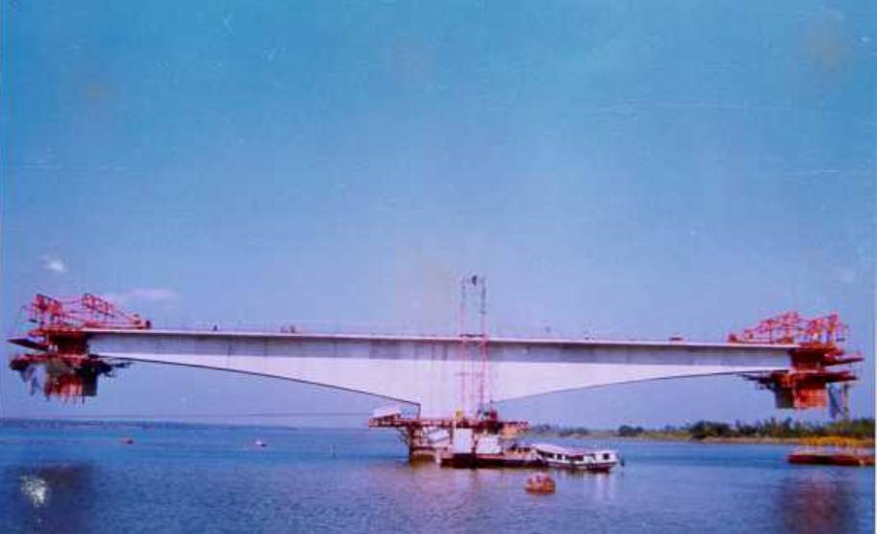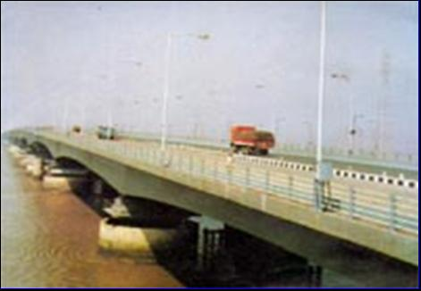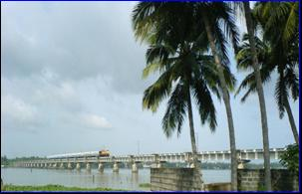

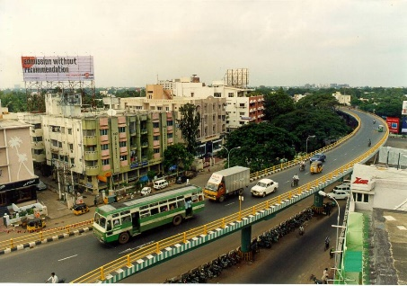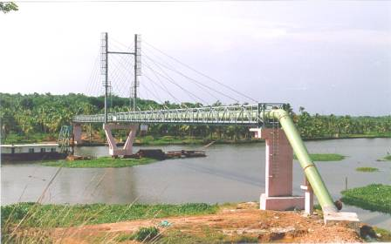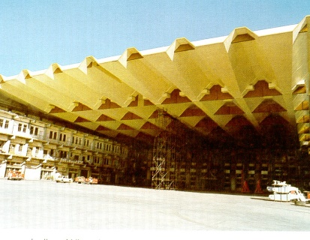

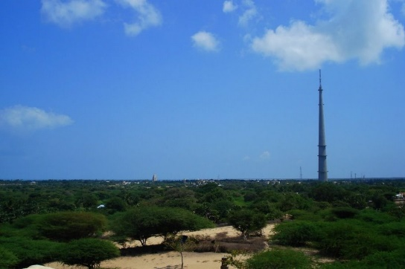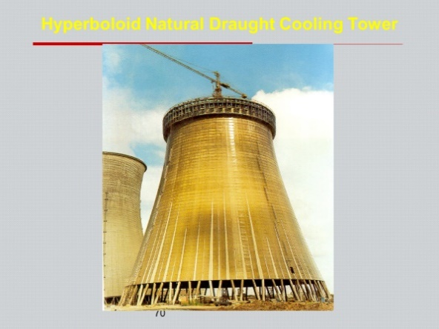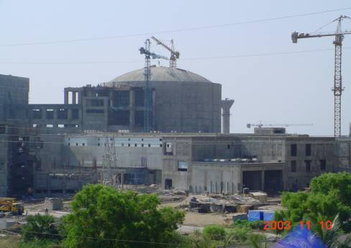

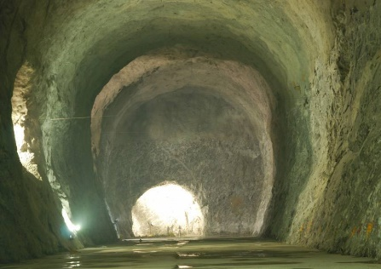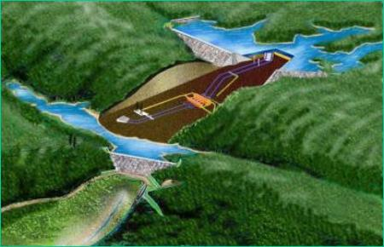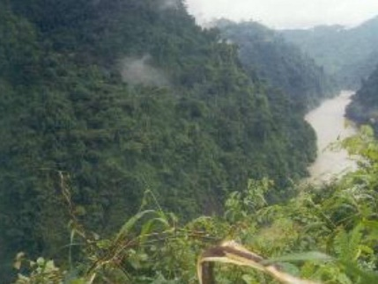

**1 Second Thane Creek Road Bridge- first constu-inuous long span bridge with mnay dyability measures**

**2. cable-stayed pipe bridge at Cochin**

**3.62 m long catilevering span folded plate rof for aircraft hangar at Mumbai**

**4. 323m tall TV Tower at rameswaram**

**5. Hyperboloid Natural draught Coling Towera**

**6. 2x500 MW Tarapur atomic Power Project**

**7. Underground Cavern 125,000 cum capacity for strategic storage of LPG 200 m blow ground at Vizag**

**8. Pumped Storage Project at {urulia**

**9. 2000 MW Subansiri Hydeo electric projetc Powerhouse location**